Answers 7

07a.dta
This is a large set of data on patients receiving adjuvant therapy after surgery for colon cancer. Describe this data set and determine which, if any, variables are prognostic in this patient group.

The data list the number of days of follow-up (survival_time), whether the patient was dead or alive at last follow-up (died), sex, age and various characteristics of the colon tumor. First we have to tell Stata that this is survival data: “stset survival_time, f(died)”. We can then type “stsum” to get median survival and “sum s if died==0, detail” to get median length of follow-up for survivors. To look at predictors of survival, we might conduct a multivariable regression:

stcox sex age obstruction perforation adhesion nodes

This suggests that the presence of obstruction or adhesion influences survival, as well as the number of nodes. Neither age (surprisingly) nor sex are likely to have a large impact (the confidence interval does not include any large differences between groups). The p value for perforation is non-significant, but the confidence intervals are wide. Why is this? Try “tab perforation” and you will see that less than 3% of patients had perforations, making it almost impossible to assess its predictive value. Another useful thing to do is to try “tab nodes”. You can see that patients had up to 33 nodes affected, yet all but a handful had 10 or fewer nodes. This might make us somewhat suspicious of the coefficient for nodes (which is interpreted as increase in hazard ratio for each additional node). One possibility might be to:

g n2=nodes
replace n2=. if nodes>10
stcox sex age obstruction perforation adhesion n2

This creates a new variable that excludes patients with large numbers of nodes from the analysis. However, it might be better to group patients. Here we create a new variable called “node4” that groups patients into four groups: 0 – 2 nodes, 3 – 5 nodes, 5 – 10 nodes, 11 or more nodes.

g node4=1
replace node4=2 if nodes>2 & nodes<6
replace node4=3 if nodes>5 & nodes <11
replace node4=4 if nodes>10
replace node4=. if nodes==.

The “cut-points” are arbitrary but are not particularly important unless you think the effect of nodes radically changes at one particular cut point or another. Also note the last line: Stata counts missing data as infinity. So if you type “replace node4=4 if nodes>10”, anyone with missing data for nodes will be give node4=4.

The regression code would then be:

xi: stcox sex age obstruction adhesion i.node4

A model answer for this data set might be:

Median survival in the 614 patients in the cohort was 8.0 years [note: I converted this from days] with a median duration of follow-up for survivors of 6.4 years. There were 284 deaths during follow-up. Although about 95% of patients had ten nodes or fewer, a small number of patients had a very large number of affected nodes, up to 33 in one case. Nodes were therefore categorized as 0-2, 3-5, 6-10, 11+. In a Cox regression of the 599 patients with complete data, obstruction, adhesion and number of nodes were predictive of survival. Neither sex, age or perforation appeared to influence survival. Fewer than 3% of patients experienced perforation and this variable was therefore removed from the model. Results for the final model are given in the table.

Predictor | Number of patients | Hazard ratio | 95% C.I. | p
Sex: male | 296 (48%) | Reference
Sex: female | 318 (52%) | 0.99 | 0.78, 1.26 | 1
Age |  | 1.01 per year | 0.99, 1.02 | 0.3
No obstruction | 486 (81%) | Reference
Obstruction | 113 (19%) | 1.44 | 1.07, 1.93 | 0.015
No adhesions | 514 (86%) | Reference
Adhesions | 85 (14%) | 1.41 | 1.03, 1.93 | 0.032
Number of nodes
0 – 2 | 311 (52%) | Reference
3 – 5 | 168 (28%) | 1.62 | 1.21, 2.16 | 0.001
6 – 10 | 92 (15%) | 2.93 | 2.14, 4.02 | <0.0005
11 + | 28 (5%) | 3.30 | 2.06, 5.29 | <0.0005

07b.dta
These are time to recurrence data on forty patients with biliary cancer treated at one of two hospitals, one of which treats a large number of cancer patients and one of which does not. Do patients treated at a “high volume” hospital have a longer time to recurrence?

Well after we “stset time, f(recurrence)”, we can test the difference between groups by typing “sts test hospital”. We get a p value of 0.11. This is not sufficient evidence to conclude that high volume hospitals and more experienced surgeons lower recurrence rates. However, could there be a difference and the trial was not large enough to detect it? The key point here is not sample size, but the number of “events” (typically recurrences or deaths). Even if you had a trial of 100,000 patients, if only one or two people died you would not have any data on length of survival to test. In this data set, though there were 40 patients, there were only ten events. You can see that if you type “stset”.

You can then “stcox hi” to find that the hazard ratio for survival is 0.35. The 95% C.I. is 0.1, 1.4. Clearly, high volume hospitals seem to do better, this data set just isn’t large enough to see it.

A “model answer”:

At a median follow-up for survivors of 44 months, three patients in the high volume hospital had died compared to seven in the low volume hospital (see figure, p=0.11 by log-rank test). Median survival has not been reached in either group. The hazard ratio of 0.35 ( 95% C.I. is 0.09, 1.35) suggests that a large difference between groups may not have been detected at this stage of follow-up.

Another way of doing this would be to estimate survival at say, 6, 12 and 18 months in each hospital. The command would be "sts list, at(183 365 548) by(hospital)" and you could report survival of 100%, 90% and 85% in the high volume hospital compared to 90%, 75% and 56% in the low volume hospital.

07c.dta
These are data from a randomized trial comparing no treatment, 5FU (a chemotherapy agent) and 5FU plus levamisole in the adjuvant treatment of colon cancer. Describe the data set. What conclusions would you draw about the effectiveness of the different treatments?

Let’s jump straight to the model answer.

The study cohort consisted of 929 patients, of whom 452 died during the study. Median duration of follow-up for survivors was 6.4 years. Median survival in the control and 5FU group groups was 5.7 and 5.9 years respectively; median survival for the combination group has not been reached (see figure). The overall log-rank test was significant (p=0.003), suggesting that the survival is different between groups. In a multivariable Cox regression with group coded as two dummy variables (5FU and Levamisole), 5FU was found to have little effect on survival (hazard ratio 0.97, 95% C.I. 0.78, 1.21; p=0.8). Levamisole, however, led to significantly increased survival (hazard ratio 0.71; 95% C.I. 0.56, 0.90; p=0.004).

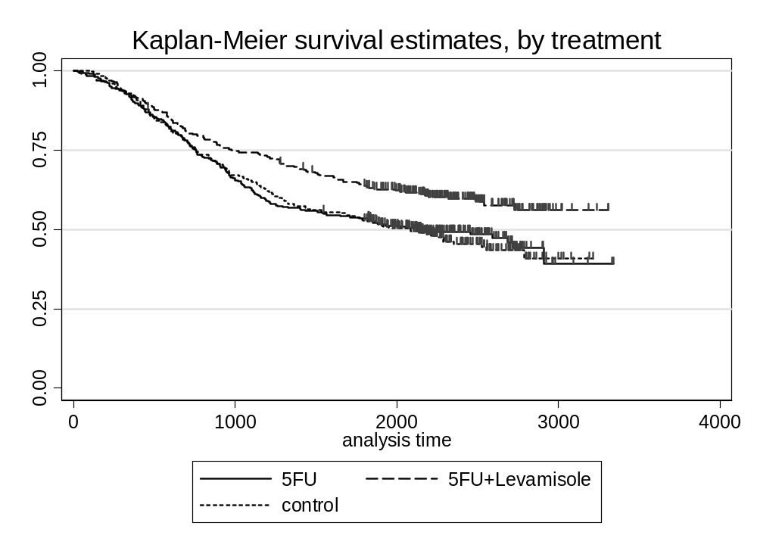

In case you are wondering how I did all this, one key is to see that in the data set “group” and “treatment” are equivalent: try “tab group treatment”. When I did the graph, I typed “sts graph, by(treatment)” to get the names of the treatment on the graph. When I did the Cox regression, I created dummy variables by typing:

g fu=0
replace fu=1 if group==3
g lev=0
replace lev=1 if group>1

Then it was straightforward to type “stcox fu lev”. The overall p value reported was obtained by typing “sts test group”. You can also make pairwise comparisons by typing, for example, “sts test group if group>1”. The p values are the same as the ones you get from the Cox model. So why do the Cox model? It is to get the hazard ratios, that is, to produce data in a clinically meaningful way.

Any oncologists notice a problem here? It is this: Levamisole doesn’t work at all, but 5FU (obviously) does. It turns out that this whole data set (which I downloaded from the internet) was miscoded: it should have been: control, levamisole alone, levamisole + 5FU. Which goes to show the importance of checking your data.

07d.dta
More data on time to recurrence by hospital volume. Given this data set, determine whether patients treated at a “high volume” hospital have a longer time to recurrence.

These data are comparable to 07b.dta, except with a longer length of follow-up. There are more recurrences (events) because more time has elapsed. So though the hazard ratio is very similar, and the number of patients identical, the confidence interval is much narrower and the results statistically significant. However, do be careful about drawing causal inferences: just because survival is better at the high volume hospital, it doesn't mean that treatment at a high volume hospital improves survival. There may be other differences between hospitals (e.g. case mix).

